MINI SCIENTIFIC RESEARCH REPORT
- Title
Combined solution of current methods based of analysis about procrastination and productivity.

- Background
- Identified Problem:
Many people struggle with procrastination. Although they use productivity or anti-procrastination apps, they often return to their old habits after a short time.
- Problem Importance:
Procrastination lowers productivity, increases stress, and makes it difficult for people to complete tasks and achieve their goals in the long term.
- Supporting Data:
“... In 2026, the global average screen time across all devices has reached 7 hours per day ... when you isolate smartphones specifically ... the global average sits at 4 hours and 37 minutes a day.” (Dhoker, 2026)

- Research Findings
- Trend Observation:
More people are using productivity and anti-procrastination apps to help them manage their time better. These apps often improve productivity in the short term, but not in a long term.
- Consumer Needs:
People need a solution that helps them stay productive for the long term. A solution that combines productivity tools with social support can help reduce procrastination more effectively.
- Supporting Screenshots:
- 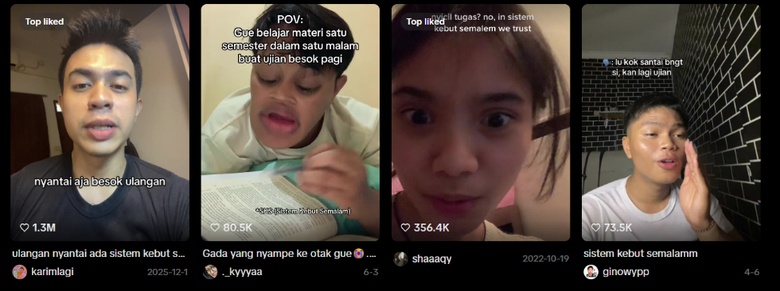
- 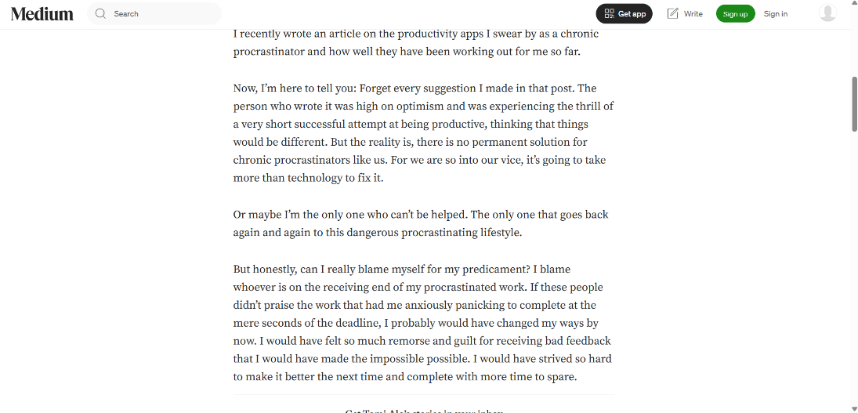
- 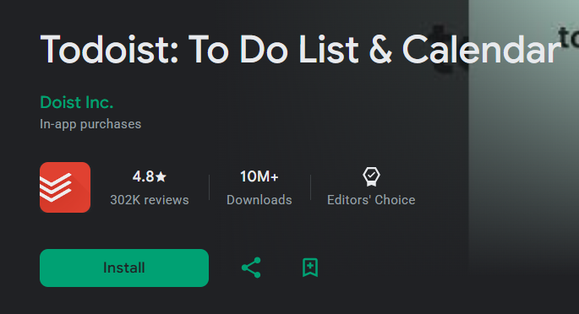
- Proposed Solution:
- Product Idea:
Develop a productivity app that combines task management with social support. The app includes daily task planning, reminders, and an accountability feature where friends or family can encourage and monitor progress.
- Expected Benefits:
- Encourages lasting behaviour change instead of relying on temporary motivation.
- Helps people recognize and overcome procrastination triggers before they become habits.
- Builds a supportive environment where people can be motivated through socializing.
- Conclusion
- Problem:
Many people struggle with procrastination and have a hard time of overcoming procrastination in a long term. Meanwhile, solutions like productivity apps or productivity techniques only works in a short term for most of them.
- Solution:
To fulfill the demands of overcoming procrastination in a long term, we decided to make a combined solution which is combining social support along with productivity apps that helps using the productivity app in a long term and putting away the phone a habit.
- Evidence:
- https://habitdoom.com/blog/screen-time-statistics-2026
- https://medium.com/@tomialo/why-productivity-apps-cant-cure-my-procrastination-47e909f42787
- https://www.ipb.ac.id/news/index/2025/08/ipb-university-lecturer-procrastination-triggers-mental-health-issues/
- https://www.inc.com/jessica-stillman/anti-procrastination-apps-actually-work-study-says.html

Works Cited
Dhoker, N. (2026, March 5). Blog. Retrieved from Habitdoom: https://habitdoom.com/blog/screen-time-statistics-2026

9A Research Group:
- Alvin
- Richard
- Kim
- Felice
- Janet
- Keyser
- Gracelynn
- J. Lionel

